**Kocaeli University, Electronics and Telecommunications Engineering Department**

**Digital Communications Laboratory**

**Experiment 4: BASK Modulation and Demodulation - Lab Report** **(25.03.2024)**

|  |
| --- |
| Name-Surname-Number: |
| Name-Surname-Number: |
| Name-Surname-Number: |

**SIMULINK PART - The table below is for verification only and filled by the lab instructor.**

|  |  |
| --- | --- |
| Understanding Carrier existence in BASK (10 pts) |  |
| Understanding bandwidth and power consumption of BASK (10 pts) |  |
| Understanding the Synchronous Demodulation of BASK (10 pts) |  |
| Understanding the Asynchronous Demodulation of BASK (10 pts) |  |

**STM32 PART - Section 1: Transmitting a Data Byte Using BASK Modulation**

**Step 1:** Set the carrier frequency and txData values as **it is given on the whiteboard**. Build STM32 code and flash the MCU then reset it, you don’t need to run MCU in debug mode.

**Step 2:** Connect NI Elvis II Scope CH0 to **Frame Sync Signal (D8 on Nucleo-64 or PA9 on Discovery)**.

**Step 3:** Connect NI Elvis II Scope CH1 to **Clock Signal** **(D13 on Nucleo-64 or PA5 on Discovery)**.

**Step 4:** Adjust the Scope divisions (1V/Div, 500µS/Div). Set Scope CH0 vertical position at -3V. Set your Scope “Trigger Type” to “Edge”, “Level” to “1V” and Trigger “Source” to “Scope CH0”.

**Step 5:** How many Clock Signal Cycles (periods) between two Frame Sync Signal Pulses? Fill the Table below. (5 pts)

|  |  |
| --- | --- |
| **Clock Cycle Counts** |  |

**Step 6:** Disconnect Scope CH1 from Clock Signal and connect it to **BASK Modulation output** **(A2 on Nucleo-64 or PA4 on Discovery).**

**Step 7:** Plot your Scope screen on the graph. (10 pts)

**Section 2: Exploring Frequency Spectrum of BASK Modulation**

**Step 8:** Stop the Scope then Open NI Elvis II DSA. Adjust the DS parameters as listed int the table below:

|  |  |
| --- | --- |
| **Source Channel** | SCOPE CH1 |
| **Frequency Span** | 40000 |
| **Units** | dB |

**Step 9:** Observe the frequency components which have magnitude above -40dB, Fill the first four ones in the table below. (10 pts)

|  |  |
| --- | --- |
| **Frequency (kHz)** | **Magnitude (dB)** |
|  |  |
|  |  |
|  |  |
|  |  |

**Section 3: Asynchronous Demodulation of BASK**

**Step 10:** We can use an **Envelope Detector** circuit to demodulate any amplitude modulated signal (including BASK). Construct the Envelope Detector circuit below (R1 is a 10kΩ potentiometer).

**Step 11:** Disconnect Scope CH1 from BASK Modulation output. Connect BASK Modulation output to Envelope Detector circuit input **(Env Input)** and Scope CH1 to Envelope Detector circuit output **(Env Output)**.

**Step 12:** Build a voltage divider using a potentiometer (place it on a breadboard) and connect the variable voltage pin of the potentiometer **(Vref)** to **Comparator input (-) pin (A0 on Nucleo-64 or PA0 on Discovery)**.

**Step 13:** Connect **Env Output** to **Comparator input (+) pin (A1 on Nucleo-64 or PA1 on Discovery)**.

**Step 14:** Disconnect Scope CH0 from Frame Sync Signal. Connect **Comparator output pin (D12 on Nucleo-64 or PA6 on Discovery)** to Scope CH0. (10pts)

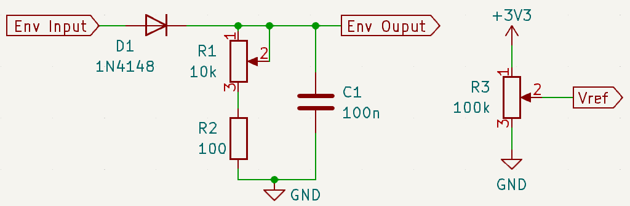

**Step 15:** Set R1 value to 0 Ω then increase it gradually until getting rid of ripple in **Env Output** (Check it by monitoring Scope CH1). Write the resistance value in the table below. (5 pts)

|  |  |
| --- | --- |
| **R1 value (kΩ)** |  |

**Step 16:** Set R3 value to output 0V from **Vref** node then increase it gradually until obtaining the demodulated signal clearly (Check it by monitoring Scope CH0). Write the resistance value in the table below. (5 pts)

|  |  |
| --- | --- |
| **R3 value (kΩ)** |  |

**Step 17:** Plot your Scope screen on the graph. (10 pts)

**Section 4: Comments on BASK Demodulation**

**Step 18:** Answer the question written on the whiteboard. (5 pts)